**GWATCH: A Web Platform for Automated Gene Association Discovery Analysis**

Anton Svitin, Sergey Malov, Nikolay Cherkasov, Paul Geerts, Mikhail Rotkevich, Pavel Dobrynin, Andrey Shevchenko, Li Guan, Jennifer Troyer, Sher Hendrickson-Lambert, Holli Hutcheson Dilks, Taras K. Oleksyk, Sharyne Donfield, Edward Gomperts, Douglas A. Jabs, Mark Van Natta, P. Richard Harrigan, Zabrina L. Brumme, and Stephen J. O’Brien

**Supplementary Information:**

Supplementary Materials and Methods

Supplementary Figures 1-4

Legends for Supplementary Figures 5, 6

Legends for Supplementary Tables 1-7

Supplementary Table 8

Supplementary References

**Supplementary Materials and** **Methods**

Different tests for analysis of associations in the various types of data are included into GWATCH. User having clinical and genotype data for one or several populations can select appropriate group of tests for screening statistical associations of infection or disease progression with genotypes. Results of all selected statistical tests are visualized simultaneously in the HIGHWAY browser. Most of statistical tests are executed using R-project. A special option allows displaying detailed results of statistical analysis for any selected SNP (TRAX report).

**1. Statistical data**

Input data for the analysis consist of clinical data and genotype data. The genotype data contain information on all SNPs to be analyzed and the corresponding genotype consists of two dummy (binary) variables specifying corresponding forms of two alleles or of one categorical variable with three levels specifying whole genotype information for the individual. In the former case 0 corresponds to common SNP allele and 1 corresponds to minor SNP allele. In the latter case common SNP homozygote is coded by -1, minor SNP homozygote is coded by 1 and heterozygote is coded by 0. The required SNP information is SNP identifier (SNP ID) and the corresponding coordinate. The input genotype data are expected to be sorted by SNP coordinate sequentially. For further analysis all individuals will be subjected to different types of genotype classification.

*Genotype classification* is used as an explanatory factor for all statistical tests. Four types of genotype classification are used: dominant (D) classification separates common homozygote from all other genotypes in two different groups; recessive (R) classification separates minor homozygote from all other genotypes and codominant (CD) classification separates all individuals into three groups by their genotype; under allelic classification (A), two SNP alleles corresponding to any single individual are considered as different observations with the same clinical data.

Two types of clinical data are acceptable for analysis: categorical and right-censored survival.

*Categorical data* consist of the ID variable and numeric categorical variable having two or more levels specifying disease status. In the case of two levels it is recommended to use code 1 for affected individuals (i.e. individuals which acquire infection, demonstrate symptoms of disease etc.) and code 0 for other individuals. In the case of more than two levels and ordinal categories it is recommended to use 0 for unaffected individuals (e.g. uninfected individuals or individuals with no disease symptoms etc.) and to choose positive numbers corresponding to other levels in the same order as the original categories.

*Right-censored survival data* contain information on exact time from baseline date (preferentially in days) to an event and type of the event that is given by the binary variable: 1 corresponding to failure (event occurred) and 0 corresponding to censoring (no event), for any individual. For competing risks model it is possible to use several positive levels for different types of failures.

**2. Statistical tools for associations**

The GWATCH allows to analyze associations of disease traits with genotype for all available SNPs. Tests corresponding to different genotype classifications can be produced for any clinical data by the selected testing method. Stratified analysis is available if the input clinical data contain classification variable. In this case any selected group of individuals is analyzed separately and the results of these tests are displayed on different lanes of the Highway.

*Categorical tests (CT)* (see [1]) are used for categorical statistical analysis of data organized as m×k contingency table. The categorical data are required to perform categorical tests. Fisher’s exact test (**R**-function “fisher.test()”) for **2**×**2** contingency tables and chi-square test (**R**-function “chisq.test()”) are applied to produce p-value. The odds ratio for **2**×**2** contingency tables or the transformation of Pearson’s correlation coefficient (designated as ez2-transformation for the square of the exponentiated Fisher’s z-transformation) for the tables of other sizes define direction of the association and, therefore, color of the corresponding bar on the Highway.



*Proportional hazards survival tests (PHST)* are used for the analysis of right-censored survival data that are required for this type of tests. Cox proportional hazards model [2] is used to produce p-value (**R**-function coxph(), package *survival*). Direction of the associations is defined by the obtained relative hazard which is calculated as hazard ratio (for binary genotype classifications A, D and R) or exponentiated slope of Cox’s regression line (under CD genotype classification).

*Categorical tests for survival data (CTSD)* are used to identify significant difference between categories of individuals grouped by failure times. The right-censored survival data are required to perform categorical survival tests. Baseline null hypothesis is formulated in terms of identity of cumulative distribution functions corresponding to different groups of individuals. Individuals involved into analysis are classified by observed failure or censoring times according to specified rules.

It should be noted that categorical tests for survival data are not strictly applicable for testing categorical null hypothesis formulated in terms of interval probabilities for failure times as done in classical categorical analysis with continuous response variable. Target null hypothesis corresponding to CTSD involves censoring and lag between infection time and start of observation, as well as rules of classification. On the other hand, under mild conditions of experimental design the baseline null hypothesis implies the target null hypothesis and, therefore, rejection of the target null hypothesis imply rejection of the baseline null hypothesis.

*Hardy-Weinberg equilibrium (HWE)* tests are performed to evaluate significant deviation from Hardy–Weinberg equilibrium that is commonly used as an indicator of genotyping errors. Haldane’s exact test on Hardy–Weinberg equilibrium [3] is used to produce p-values. Sign of Hardy–Weinberg disequilibrium statistic is applied to specify direction of the disequilibrium. The **R**-function HWExact() of *HardyWeingerg* package is used to perform HWE test.

For the convenience of test results representation, several different statistics, which describe direction and strength of association between SNP and disease characteristic in different tests (odds ratio, relative hazard and ez2-transformed correlation coefficient), are combined under the general term of Quantitative Association Statistic (QAS). The QAS takes positive values. Values of QAS>1 and QAS<1 correspond to positive and negative associations, respectively.

**3. TRAX REPORTs**

After screening for associations of clinical traits and genotypes one may be interested in closer review of certain SNPs. The TRAX REPORT tool allows to produce reports on extended statistical analysis for any single SNP if the corresponding genotype information available for all individuals. Important genotype information is given in the header on the TRAX front page: SNP identifier, SNP coordinate, chromosome, alleles and their frequencies. Header also lists information on populations involved into analysis. In addition to the header, front page also contains summary for all tests with p-values and values of QAS represented for all tests in the bar plot form. Following pages of TRAX REPORT contain detailed information: contingency tables are produced in the form of corresponding bar plots for any categorical test (including progression categorical tests) and Kaplan–Meier survival curves are reported for all three genotypes for all survival tests.

**4. Statistical tools for the whole genome analysis**

Several statistical tools addressing SNP compositions are available.

*Polarization* tool allows to inverse test results for minor and common SNP-alleles around some fixed SNP (called index SNP) for better approximation of true associations. Polarization table is produced using linkage disequilibrium coefficients (*D`*) between neighboring SNPs. Linkage disequilibrium coefficients are calculated for 80 SNPs upstream and 80 SNPs downstream of the index SNP. In case of sufficiently large positive value of linkage disequilibrium (*D`* ≥ 0.9) the polarization mark is assigned to 1, whereasin case of sufficiently large negative linkage disequilibrium (*D`* ≤ -0.9) the polarization mark is assigned to -1. If linkage disequilibrium is sufficiently small, the polarization mark is assigned to 0. In the process of polarization QAS values for test results of neighboring SNPs are inverted if the polarization mark is -1 implying inversion of direction of disease association for such SNPs.

*Manhattan plots* of -log p-values are produced for any single test for all available SNPs.

*Density* top scoringthat identifies regions of concentration of small p-values is calculated for each SNP in 2 steps:

1. in the window of specified size(*n* SNPs upstream and downstream or *n* Kbp upstream and downstream) average -log p-value is computed for each test (lane of the Highway)
2. these per-test (per-lane) averages are used for calculating density at this SNP either by averaging them or by finding the largest one (depending on the option chosen)

The second step can be performed for all the tests or for the group of tests by the disease stage (e.g. all tests for HIV infection, all tests for AIDS progression etc.).

**Supplementary Figures.**

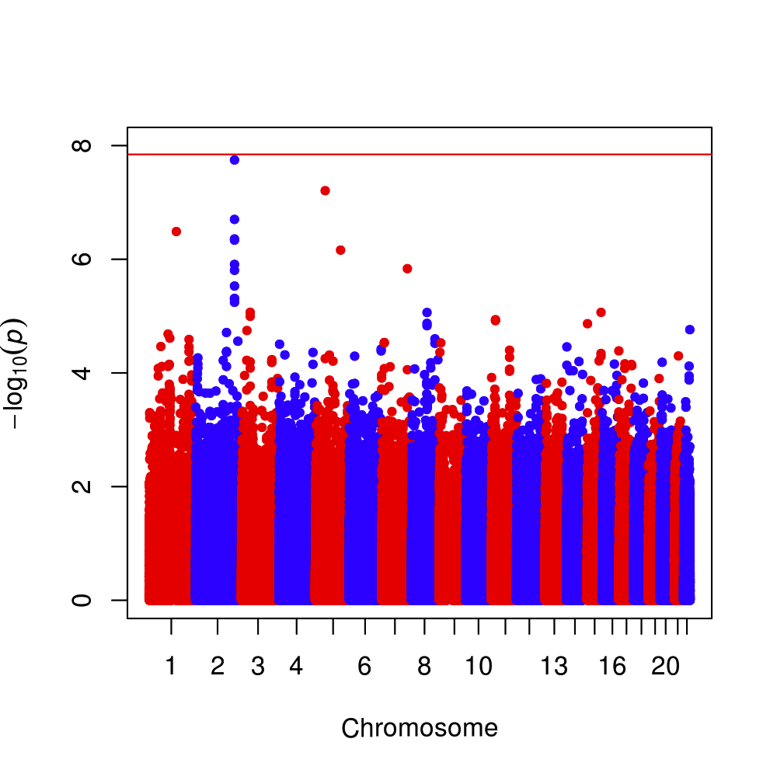

**Supplementary Figure 1. MANHATTAN** plot for one of the association tests (PHAZ/CAUCASIAN/87/D in Study Group A) that reveals SNPs in AIDS Restriction Genes.

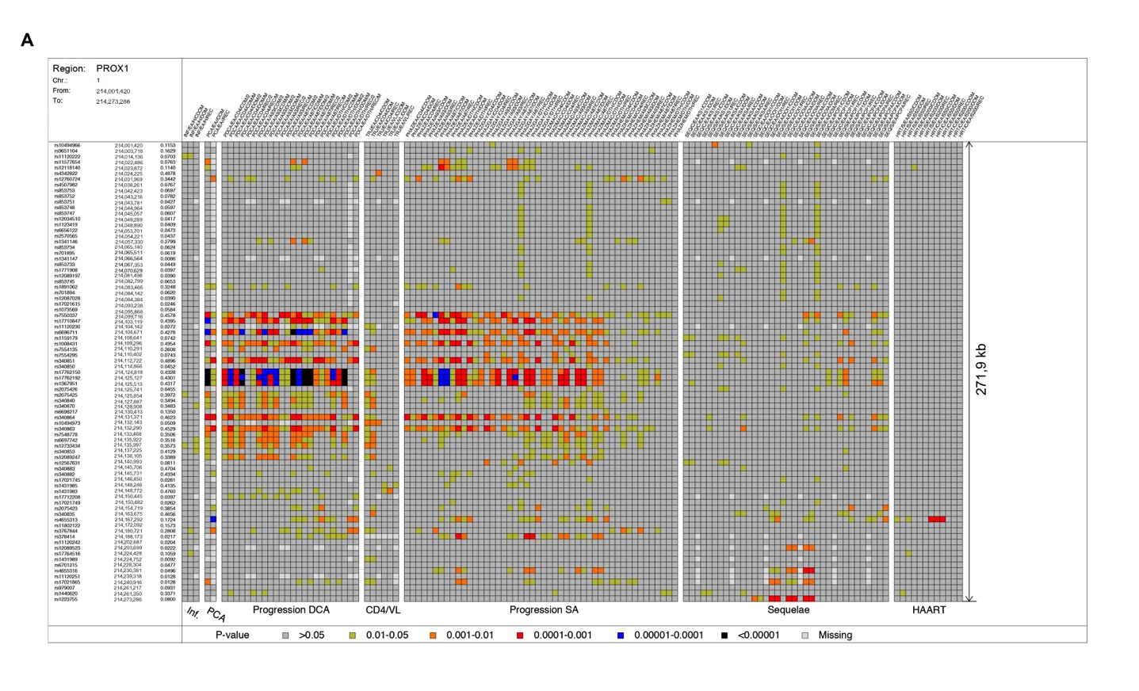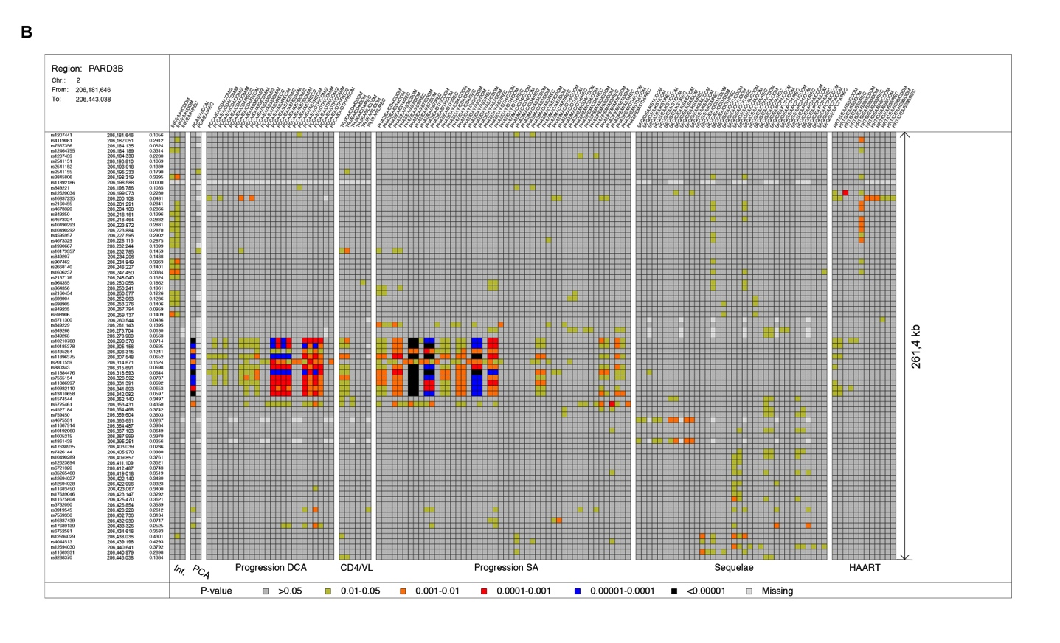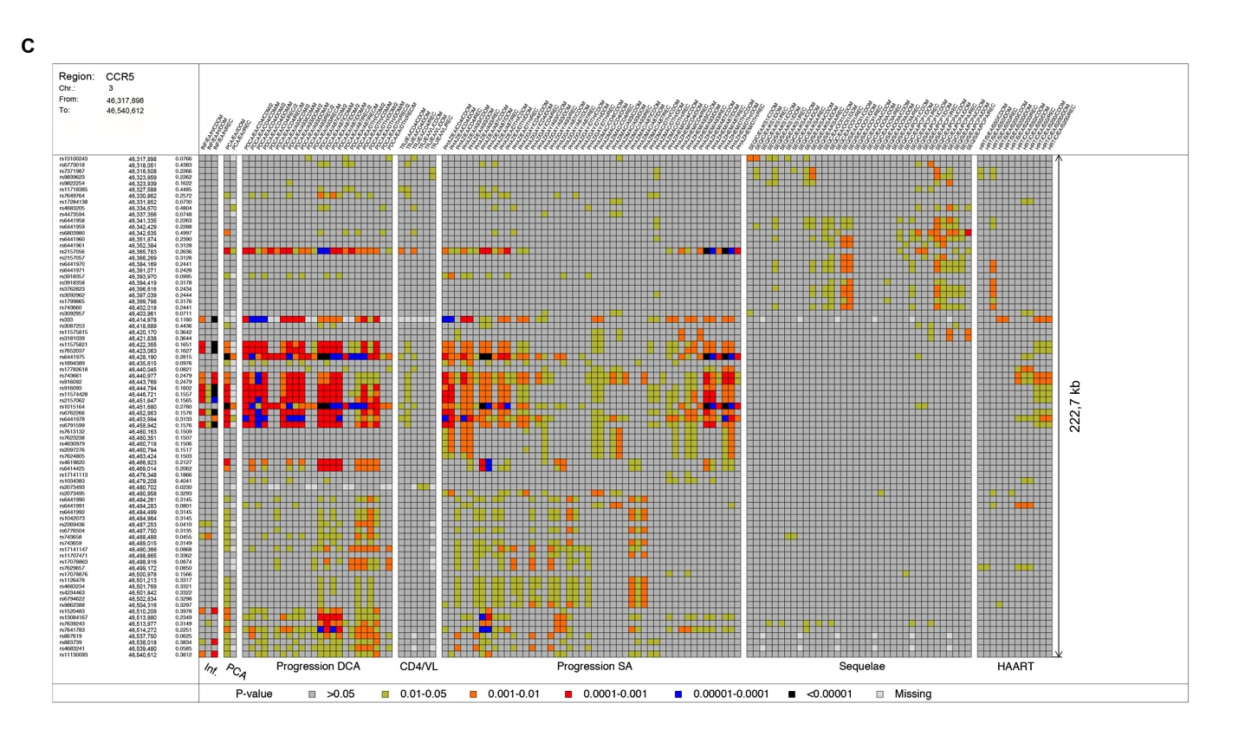

**Supplementary Figure 2**. **2D-SNAPSHOT** heat plot of selected regions illustrating significant p-values (color intensity) for association of linked SNPs alleles in: (**A**) *PROX1* (Chr. 1), (**B**) *PARD3B* (Chr. 2) and (**C**) *CCR5* (Chr. 3).

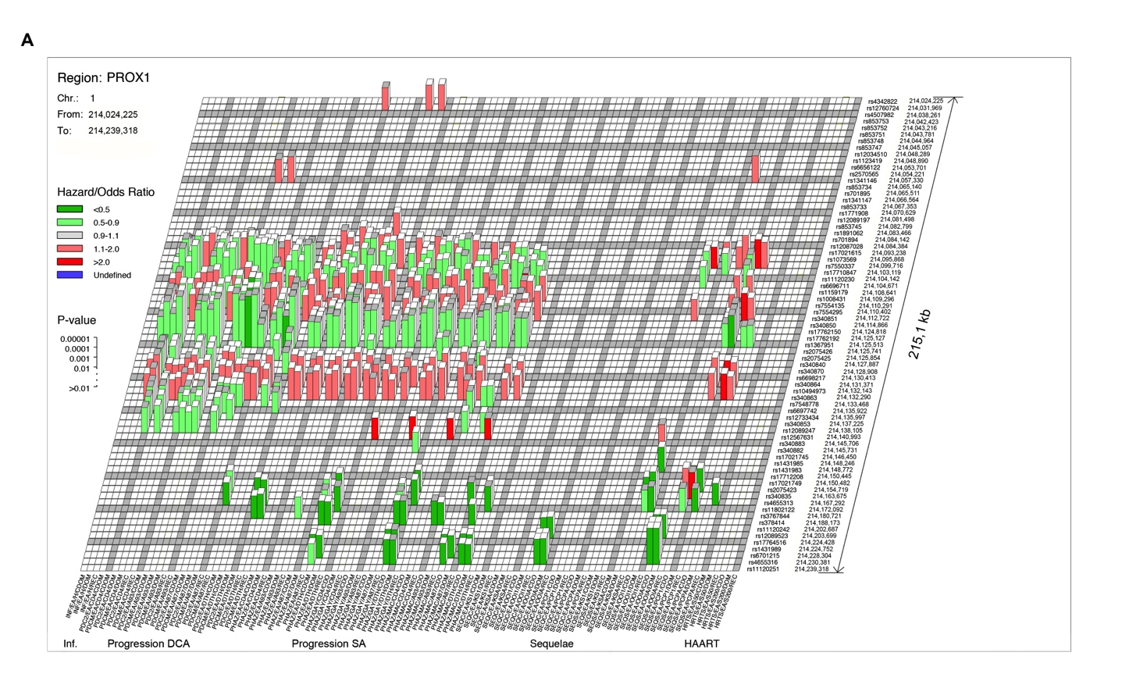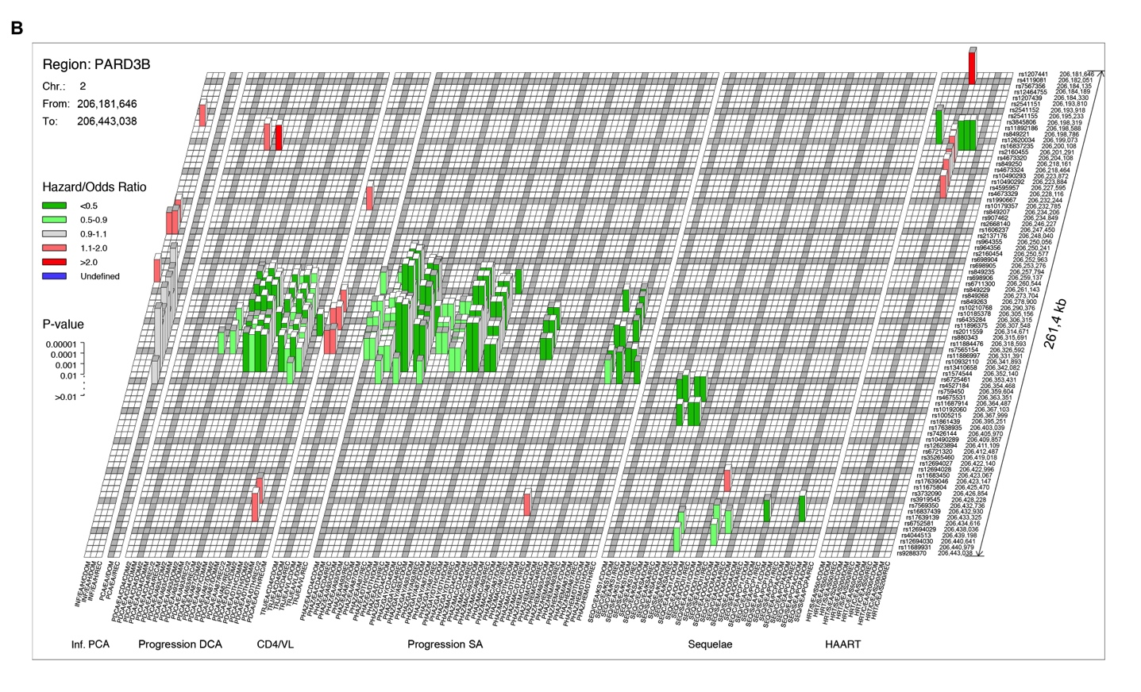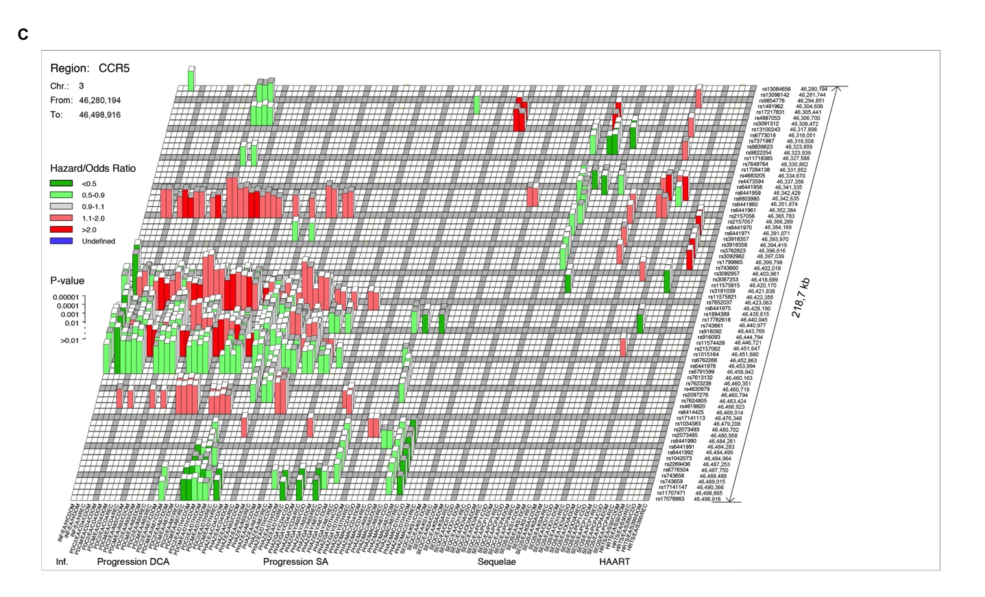

**Supplementary Figure 3. 3D-SNAPSHOT** of selected regions illustrating significant p-values (block height), QAS-based direction (color: green for QAS<1.0, red for QAS>1.0) and QAS-based strength (color intensity) of association for linked SNPs alleles in (**A**) *PROX1* (Chr. 1), (**B**) *PARD3B* (Chr. 2) and (**C**) *CCR5* (Chr. 3).

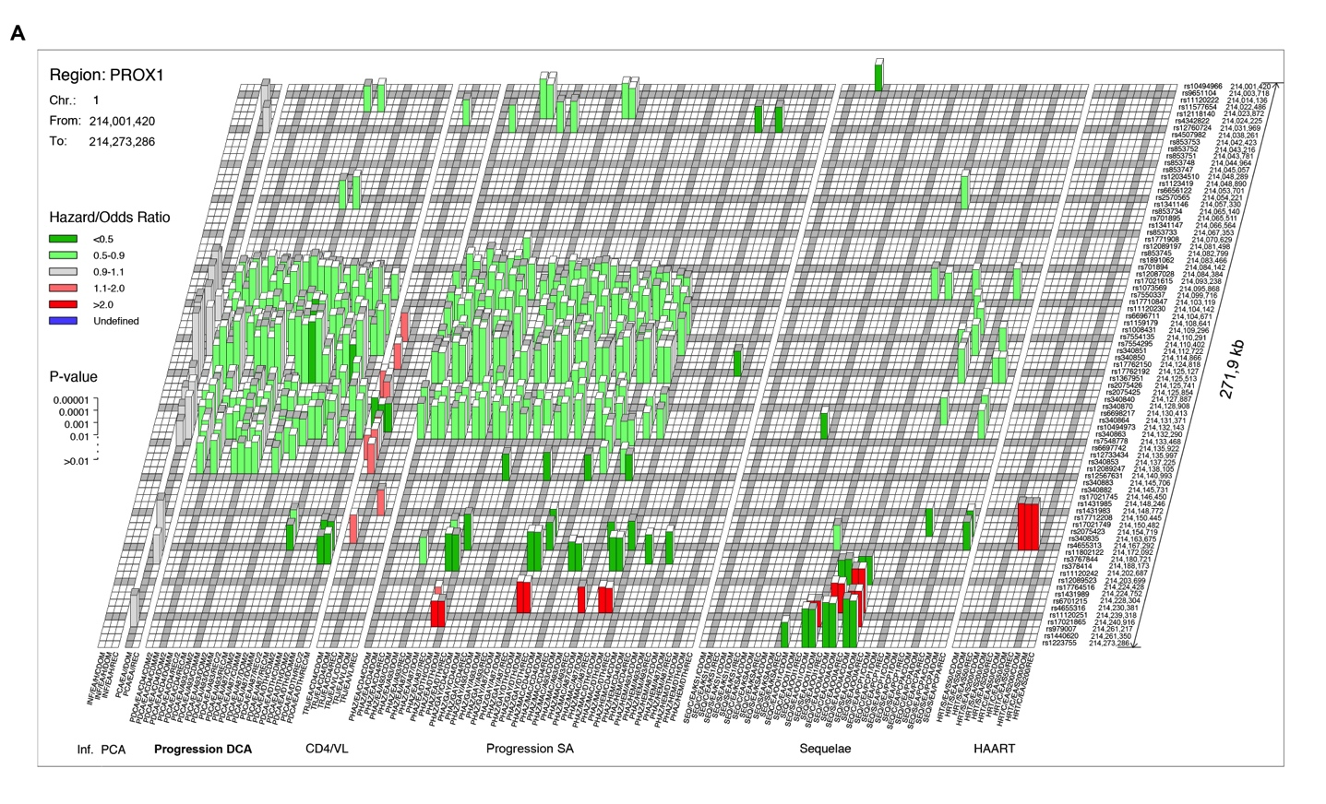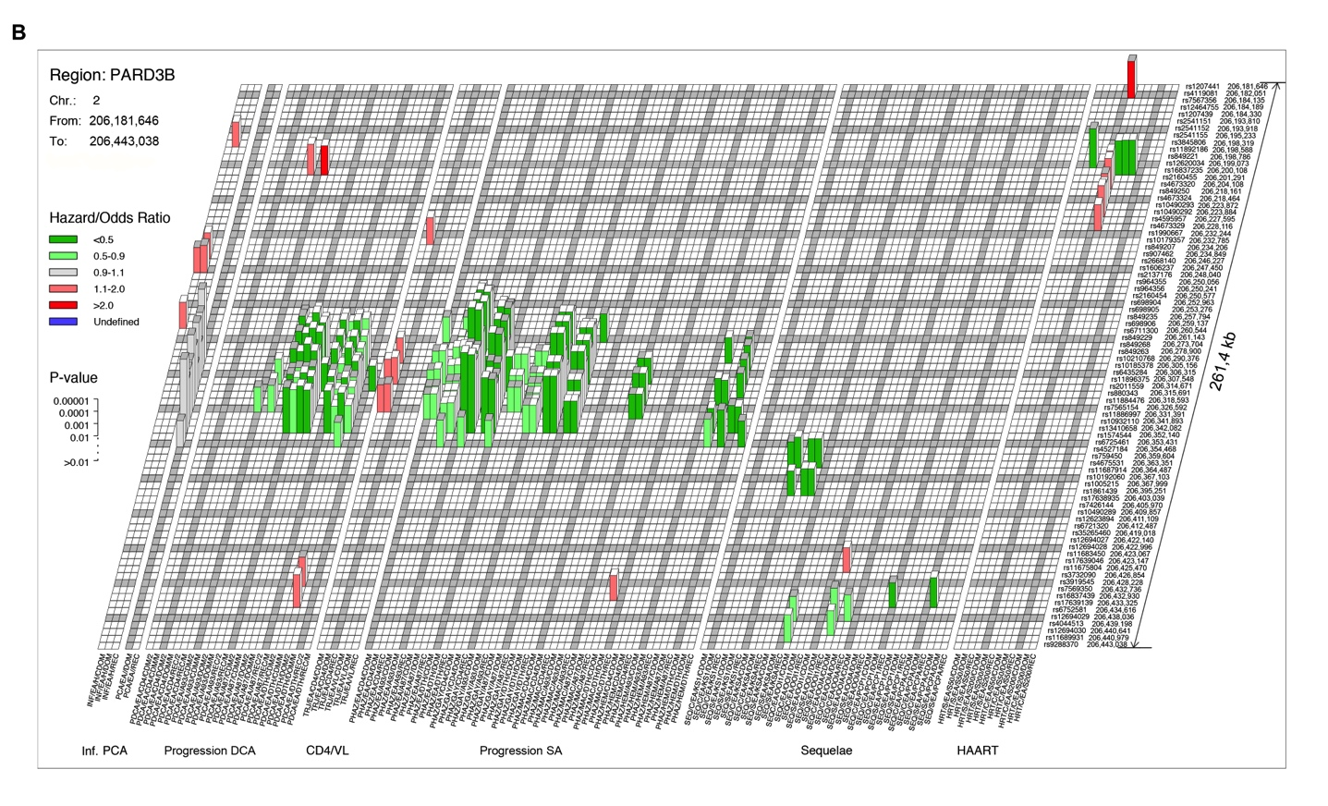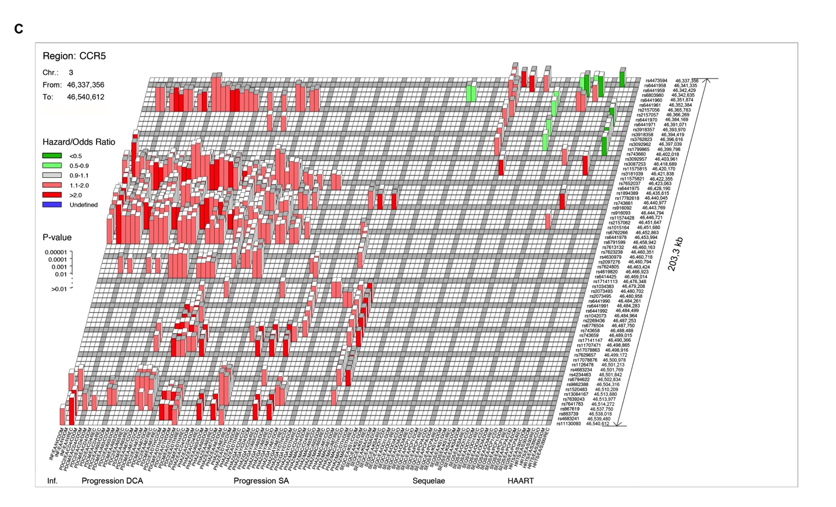

**Supplementary Figure 4. POLARIZED** **3D-SNAPSHOT** of selected regions illustrating significant p-values (block height), QAS-based direction (color: green for QAS<1.0, red for QAS>1.0) and QAS-based strength (color intensity) of association for linked SNPs alleles in (**A**) *PROX1* (Chr. 1), (**B**) *PARD3B* (Chr. 2) and (**C**) *CCR5* (Chr. 3). Polarization means the QAS values (i.e. direction of association expressed as block color) are adjusted to reflect the LD tracking of common and minor alleles at adjacent loci. This adjustment renders the colors of all proxy SNPs as the same increasing confidence that a single association signal in a gene region is driven by one causal variant tracked by proxy SNPs in LD with this causal variant.

**Supplementary Figure 5. TRAX PAGE,** 2 page summary or all test results for a single SNP for a study group (e.g. p-values and QASs for HIV infection, AIDS progression using categorical and survival tests, AIDS sequelae, and HAART outcomes can be viewed and compared). **TRAX PAGE** can be generated *de novo* for any SNP of interest by placing mouse tip over a significant tower/block in the **HIGHWAY** and selecting the TRAX PAGE option from the data window that appears (SNPs for which **TRAX REPORT** is available do not have separate TRAX PAGE option in data window since **TRAX REPORT** includes **TRAX PAGE** content).

**Supplementary Figure 6.** Detailed 11 page **TRAX REPORT** of derived statistics for all the tests accomplished including tables, bar graphs, survival curves and additional parameters for each test. **TRAX REPORT** can be generated *de novo* for the SNP of interest by placing mouse tip over a significant tower/block in **HIGHWAY** and selecting the TRAX REPORT option from the data window that appears. **TRAX REPORTs** are available for 641 SNPs in 241 human genes that were genotyped to replicate the GWAS associations for Study Groups A-C (Supplementary Table 6).

**Supplementary Tables.**

**Supplementary Table 1. Data-Table** of GWAS results: first 100 rows of the Data-Table containing SNPs, p-values and QASs for AIDS Restriction Genes in Study Group A in the *PARD3B* region of chromosome 2. Full unabridged data tables for Groups A-C are available on the web portal <gen-watch.org>.

**Supplementary Table 2.** List of SNP association statistical tests and patient counts for Study Group A.

**Supplementary Table 3.** List of SNP associations statistical tests and patient counts for Study Group B.

**Supplementary Table 4.** List of SNP association statistical tests and patient counts for Study Group C.

**Supplementary Table 5.** Summary of SNP association tests performed for each Study Group.

**Supplementary Table 6.** List of 641 SNPs within 241 human genes that were assessed to replicate the GWAS associations for Study Groups A-C. For each of these SNPs a full TRAX REPORT (11 page report of figures and tables for each test) is available on the web portal <gen-watch.org> as illustrated in Supplementary Figure 6.

**Supplementary Table 7.** Genomic regions of remarkable statistical association **(HITS)** identified in ARG-GWAS by extreme p-values, QAS or density screens.

**Supplementary Table 8.** QC filters for AIDS susceptibility Genes group A [4,5].

|  |  |  |
| --- | --- | --- |
| SNP filtering | Dropped | Included |
| Total SNPs |  | 934 968 |
| Supported SNPs | 28 346 | 906 622 |
| Autosomal SNPs | 35 456 | 871 166 |
| Perfect match probes | 3 009 | 868 157 |
| Passed HWE (p>0.001), editing, or visual inspection | 7 123 | 861 034 |
| Passed Mendelian inheritance | 389 | 860 645 |
| >95% genotyping call rate | 39 220 | 821 425 |
| MAF>1% | 121 403 | 700 022 |
| Total used |  | 700 022 |

**Supplementary References:**

1. Agresti A: *Categorical data analysis*, 2nd edition. Hoboken: John Wiley & Sons; 2002.
2. Cox DR: **Regression models and life tables.** *J R Stat Soc Series B Stat Methodol* 1972, **34**:187-220.
3. Haldane J: **An exact test for randomness of mating.** *J Genet* 1954, **52:**631-635.
4. Herbeck JT, Gottlieb GS, Winkler CA, Nelson GW, An P, Maust BS, Wong KG, Troyer JL, Goedert JJ, Kessing BD, Detels R, Wolinsky SM, Martinson J, Buchbinder S, Kirk GD, Jacobson LP, Margolick JB, Kaslow RA, O'Brien SJ, Mullins JI: **Multistage genomewide association study identifies a locus at 1q41 associated with rate of HIV-1 disease progression to clinical AIDS.** *J Infect Dis* 2010, **201:**618-626.
5. Troyer JL, Nelson GW, Lautenberger JA, Chinn L, McIntosh C, Johnson RC, Sezgin E, Kessing B, Malasky M, Hendrickson SL, Li G, Pontius J, Tang M, An P, Winkler CA, Limou S, Le Clerc S, Delaneau O, Zagury JF, Schuitemaker H, van Manen D, Bream JH, Gomperts ED, Buchbinder S, Goedert JJ, Kirk GD, O'Brien SJ: **Genome-wide association study implicates PARD3B-based AIDS restriction.** *J Infect Dis* 2011, **203:**1491-1502.